**ASSIGNMENTS ON DIGITAL MARKETING**

**NAME :** Yamini M

**DEPARTMENT :** BE COMPUTER SCIENCE

**COLLEGE :** 8151 DHANALAKSHMI SRINIVASAN INSTITUTE OF

TECHNOLOGY

**NAANMUDHALVAN COURSE**: DIGITAL MARKETING

**NM ID :** ADIF6F38C30180D8CF644CC9DD89855C

**ASSIGNMENT 1:**

Create a blog or website using Blogspot and WordPress. CustomizeThe theme design and post new article with 500 words.

<https://duskyfashions.blogspot.com/>

**ASSIGNMENT 2:**

Create a new Facebook business Page and Post one social media poster for your brand

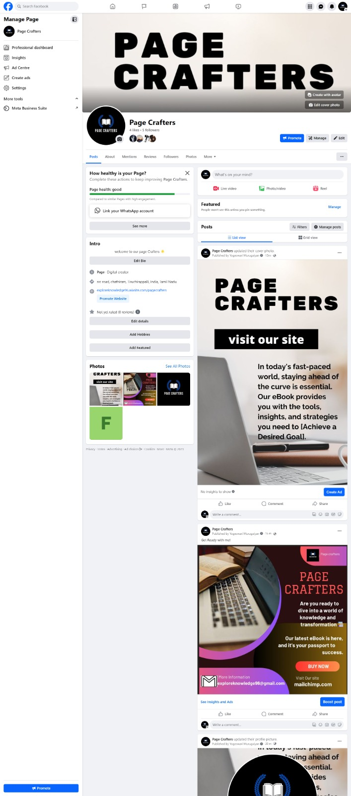

<https://www.facebook.com/people/Page-Crafters/61550192768049/>

**ASSIGNMENT 3:**

Create and design a social media advertisement poster using Canva.

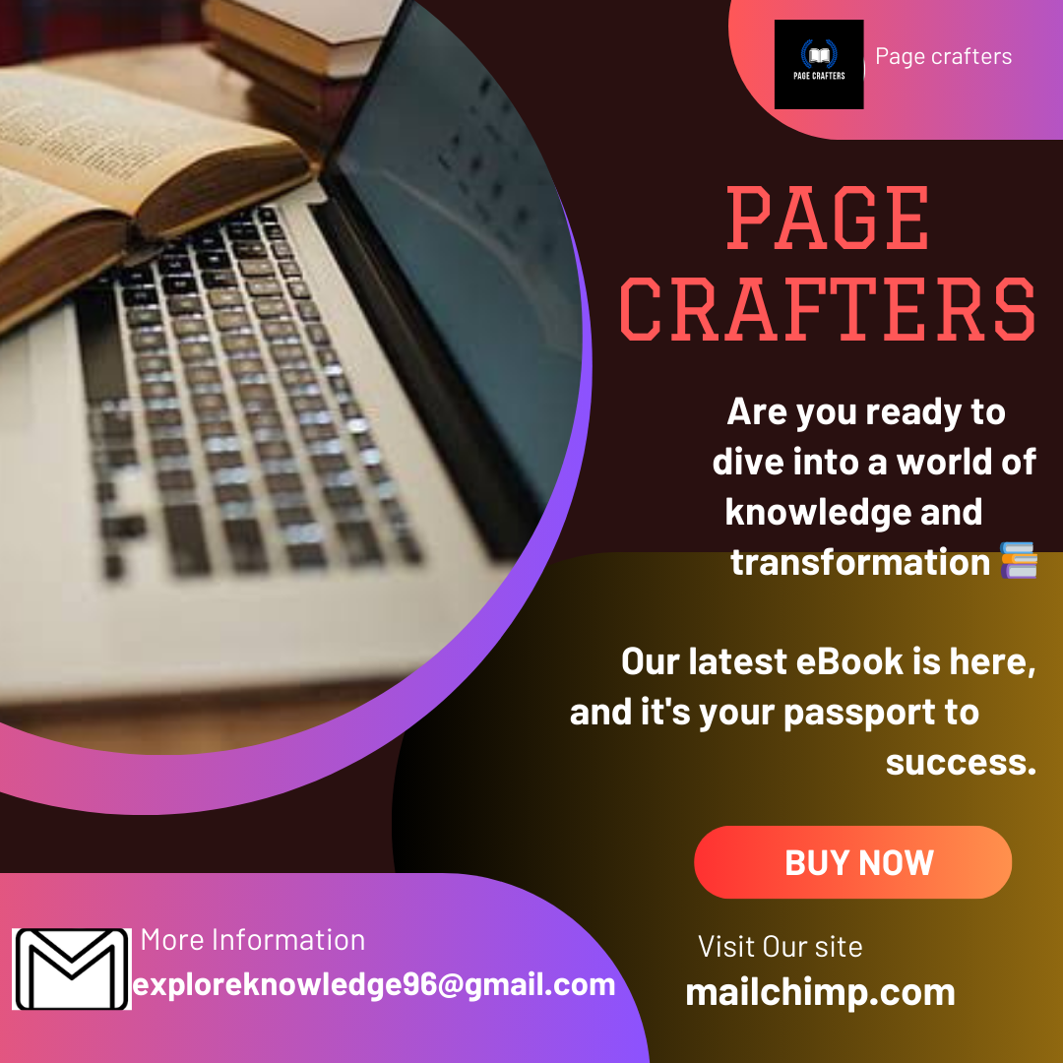

**ASSIGNMENT 4:**

4.Create email newsletter design using MailChimp or Canva tool.

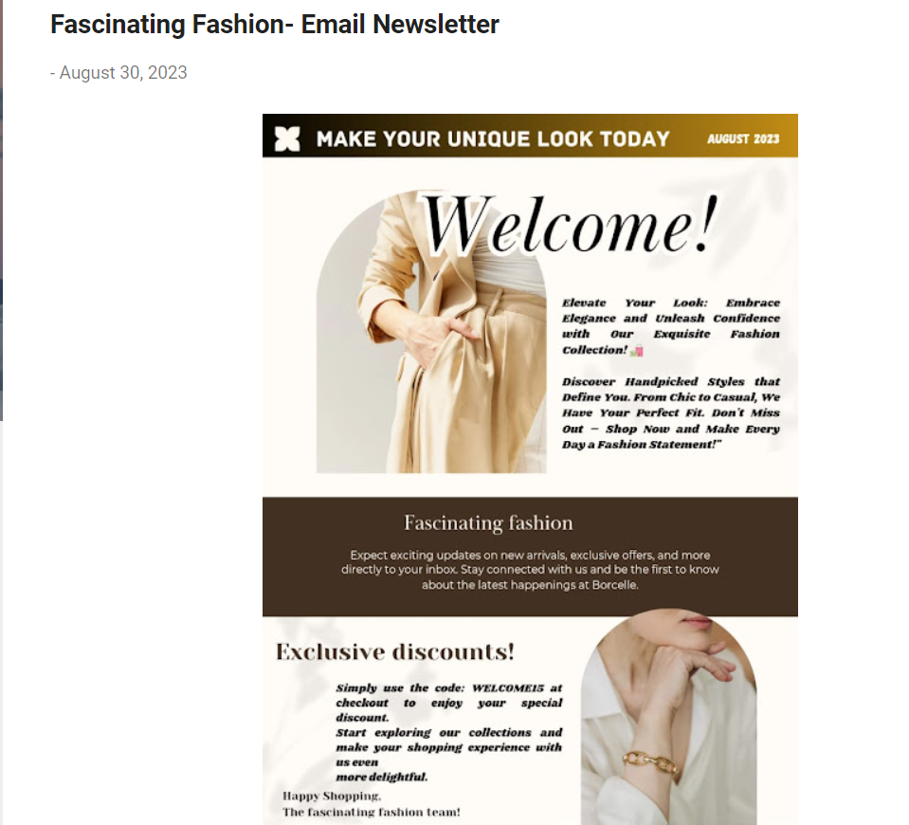

<https://duskyfashions.blogspot.com/2023/08/fascinating-fashion-email-newsletter.html>